1. Limitation of distortion of competition and trade
   1. Market affected by the state aid
      1. Current Industry Sector

DT is expected to enter two markets within the scope of the IPCEI. [1]The Long Term evolution (LTE) market and the 5G market. Both of these markets are large but growing very rapidly. . With the growing penetration of smartphones as well as increased use of video on demand, defence and public safety, surveillance, browsing, and more this demand for such services is only increasing.

The European LTE market is estimated to be 17.7billion and expected to grow at 20%[2][3] per annum such that it will be 52 billion by 2026, The European 5G market is of similar size to the LTE with 17.1bn and is expected to be over 100 billion by 2030. Both of these markets are then fast growing and will likely change structure over the coming years.

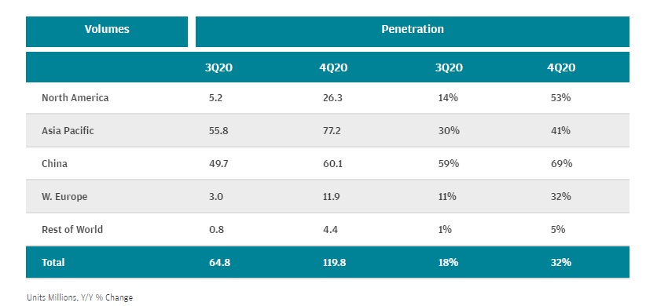[4]

From the point of view of consumers 5G is technically a better service as it allows for faster download and upload speeds, due to the industry being mostly about high CAPEX with relatively low OPEX, this means that it is reasonable to expect that demand factors will be the driving force, that is, even if 5G infrastructure is not as cost efficient as LTE, consumer demand will eventually make it dominant. In the long run, 6G will also affect the market and take market share from 5G.

Europe in particular is underdeveloped. Relative to China and the United States, the infrastructure is lacking and it is unlikely that companies will be able raise the funding required without aid.

*[5]*

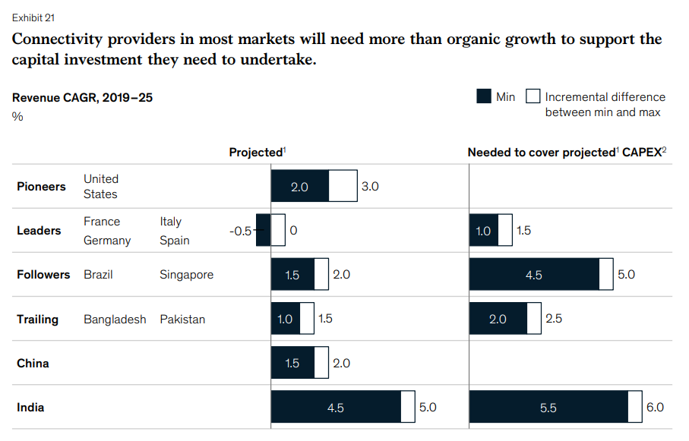

* + 1. Market Situation / Share after IPCEI

The market share in Europe of LTE

|  |  |
| --- | --- |
| Huawei | 30.8% |
| Ericsson | 29.9% |
| Nokia | 24.0% |
| ZTE | 7.7% |
| Samsung | 4.1% |
| Other | 3.4% |

For 5G, the market shares are given by[6]

|  |  |
| --- | --- |
| Huawei | 35.6% |
| Ericsson | 26.4% |
| Nokia | 14.4% |
| ZTE | 13.2% |
| Samsung | 8%% |
| Other | 2.4% |

DT then controls only very small share of the LTE and 5G markets in Europe. After the IPCEI, the share that DT will control will be identical to without the IPCEI as the O-RAN project is not a consumer side innovation but a process innovation.

* 1. Limiting distortion of dynamic incentives

The state aid required by DT for the IPCEI amounts to around 20 million. It is very small compared to the size of the respective markets (below 0.1% of market size). Moreover, about half the funding will be R&D funding, which will make it less likely to distort dynamic incentives. Finally, due to the growth rate of the market, it is very unlikely that such a small investment will have any long-term effect on the actions of other players in the market.

For these reasons it, is highly unlikely that the German state aid to DT for the IPCEI on microelectronics will deter the company’s competitors’ investments in Research and FID to develop existing technologies.

* 1. *Please describe why the IPCEI funding will not deter your competitors’ investments in R&D and FID to develop competing technologies.* No strengthening or creation of market power

There are three reasons why the IPCEI is unlikely to cause DT to become a market leader or help create market power

1. DT is currently a very small player with below 3% market share, with such dominant competitors, it is likely to get smaller over time
2. The O-RAN project increases competition, the worse case scenario is that it does not decrease market power, but the more likely case is that it will reduce total market power.
3. The IPCEI is mostly funding CAPEX and not OPEX, which means that price competition can still play a very large role in the industry.
   1. Failure to maintain an inefficient market structure

The funding towards the R&D and FID in Germany for the field of telecommunications will not adversely impact a market suffering from overcapacity nor a declining sector. For example, 5G is only available in 50% of devices in Western Europe, in other words, there is no excess capacity but an under provision of goods. Since the sector is expected to grow at unprecedented rates, it is fairly safe to say that there is no risk of maintaining an inefficient market structure.

* 1. No effect on location activities

DT’s biggest market and location of its headquarters are located in Germany. It is also the case for it’s R&D and FID activities for the IPCEI. The company did not consider locating its activities outside of Germany and did not demand funding from any other member state for the same project.

Thus there is no race to the bottom for funding between Member states for the funding of DT’s project.

1. From McKinsey Global Institute, [Connected World: An evolution in connectivity beyond the 5G revolution, 2020](https://www.mckinsey.com/~/media/mckinsey/industries/technology%20media%20and%20telecommunications/telecommunications/our%20insights/connected%20world%20an%20evolution%20in%20connectivity%20beyond%20the%205g%20revolution/mgi_connected-world_discussion-paper_february-2020.pdf)
2. https://www.industryarc.com/Report/44/global-long-term-evolution-lte-market.html
3. <https://www.graphicalresearch.com/industry-insights/1682/europe-private-lte-market>,
4. https://www.jpmorgan.com/insights/research/future-of-5g-adoption
5. https://www.jpmorgan.com/insights/research/future-of-5g-adoption
6. Both of these tables come from Dell’Oro